Initial results for Machine Learning:

Weka:

The j48 tree classify was used for the weka portion of the classifier, the target of the tree was to determine the best options for deciding if the points are a person’s leg or not.

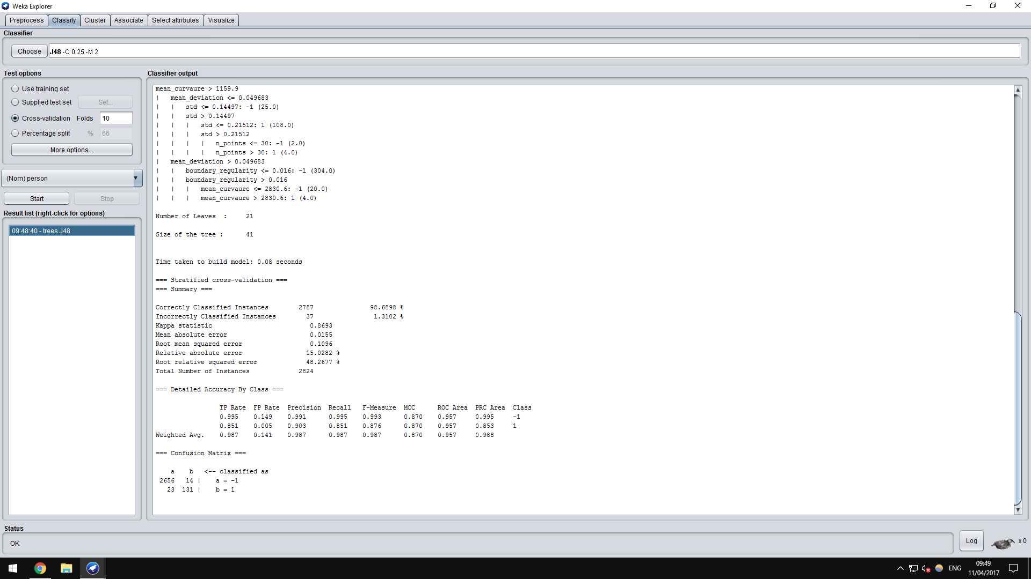

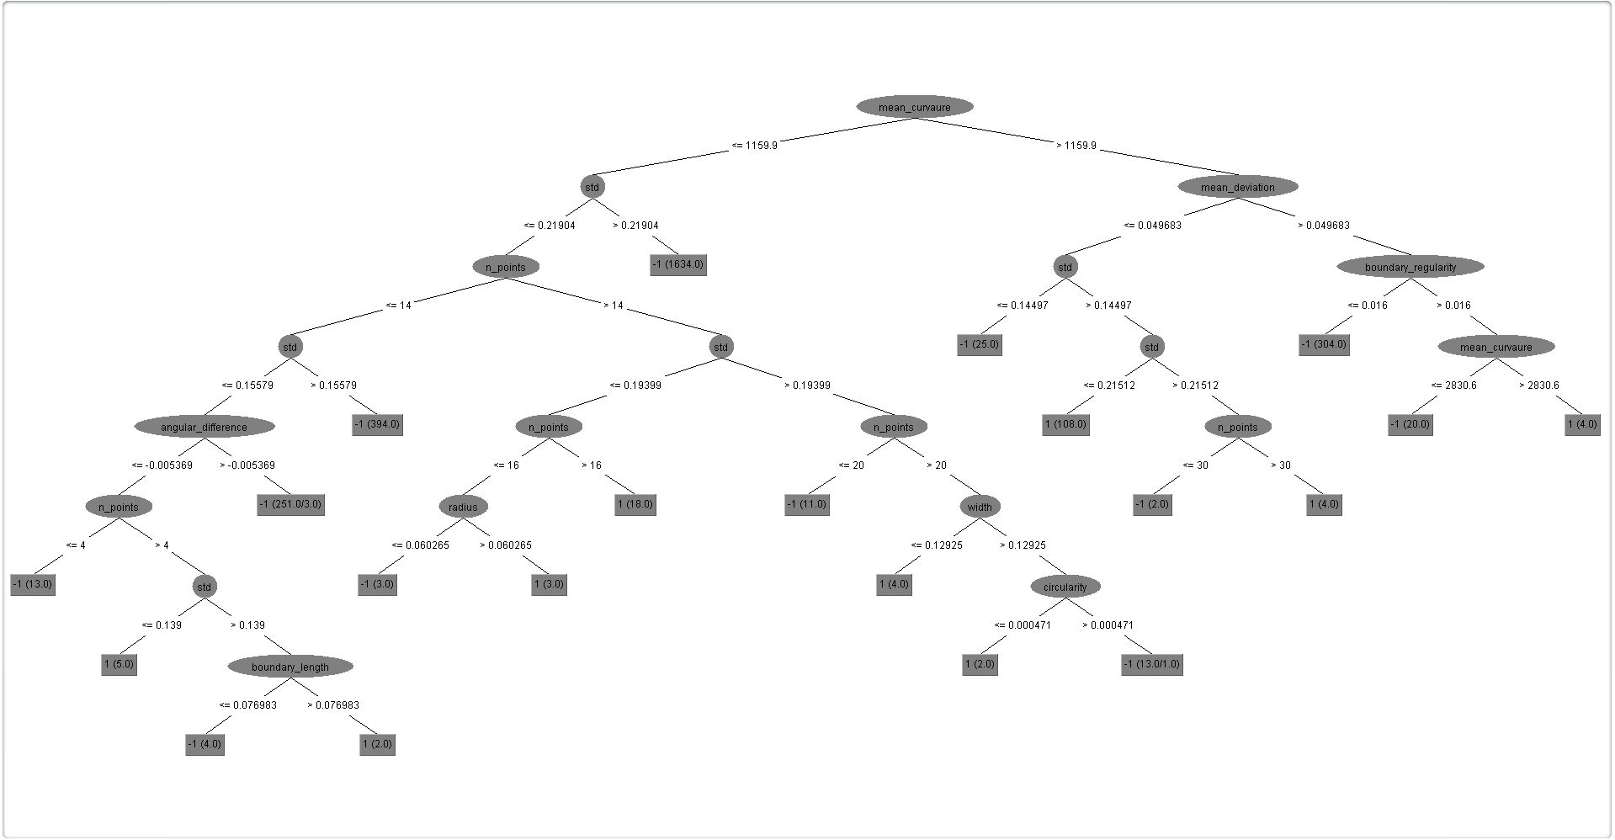

Matlab:

For the matlab part of the of the task, I used a deep neural network to carry out the classification of the dataset, using the person column of it as a the targets for the network while using the other columns of the dataset as the inputs for the data using a fitting net of [10 10] with a train to test ration of 65/35 getting the following initial results.

